STJHV Homework – Summer 1 Year 3 Core Learning: every child must complete the three tasks below -
Reading  Reading is a skill for life and a tool that will allow every child to develop as a learner.  Every Monday and Friday your child will receive a reading challenge, which they need to complete. This is child-specific to support their own pace.  Please complete the reading records to support the school in understanding your child’s progress. | Writing  This half term KS 2 pupils’ writing homework will a diary entry. Your child needs to write a whole page (but not more) for their diary entry task.  - Diary entry is due on Wednesday 8th May.  Diary entry features:  - First person (I / We)  - Past tense  - Paragraphs  - Thoughts and Feelings | Maths  15 in 15  Every Friday your child will receive 15 calculations that are linked to Year 3 expectations. These need to be completed and returned by Wednesday.  They will also receive 1 problem-solving question to extend their learning.  This task should take no longer than 15 - 20 minutes; please just do as many as you can in that time.
Homework Bingo: every child must complete at least two tasks below and hand in evidence by 22nd May.
Trips and Days Out  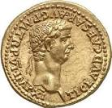  This half term we will be learning about Romans.  Do go and see the wonderful artefacts at the Museum of London! | Scientific Investigation  The most powerful magnets in the universe!  Design a power point presentation or a booklet explaining the magnetic forces which act upon the earth. | Maths  Find an old pizza box. Create or draw a pizza which is sliced into 4, 6 or 8 slices. Put on some toppings.  Create some information for the lid of the pizza box telling us what fraction of each topping is on each slice of pizza.  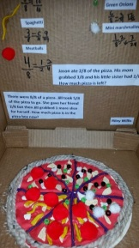
RE  Research the Buddhist Eightfold Path.  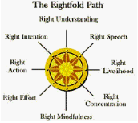  Create a leaflet (words and pictures) which explains what the Eightfold Path is, what it means and why it is so important to Buddhists. | PSHE. Relationships:  Create a poster showing a recipe for a happy friendship.  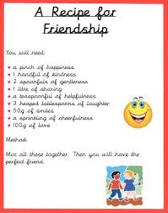 | Art & Design  A Roman helmet is called a Galea. Have a try at making your own!  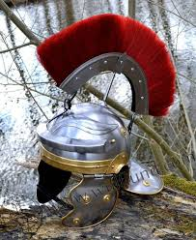

Parent Comment: Was this an enjoyable way to complete homework tasks? Did your child complete this independently or with your support?
Teacher Comment:

